How to use comparisonGenerator.exe by Xiaopei Zhang:
- Copy and paste the directory where xls files like IKIMG-2439_iq_front.xls exists
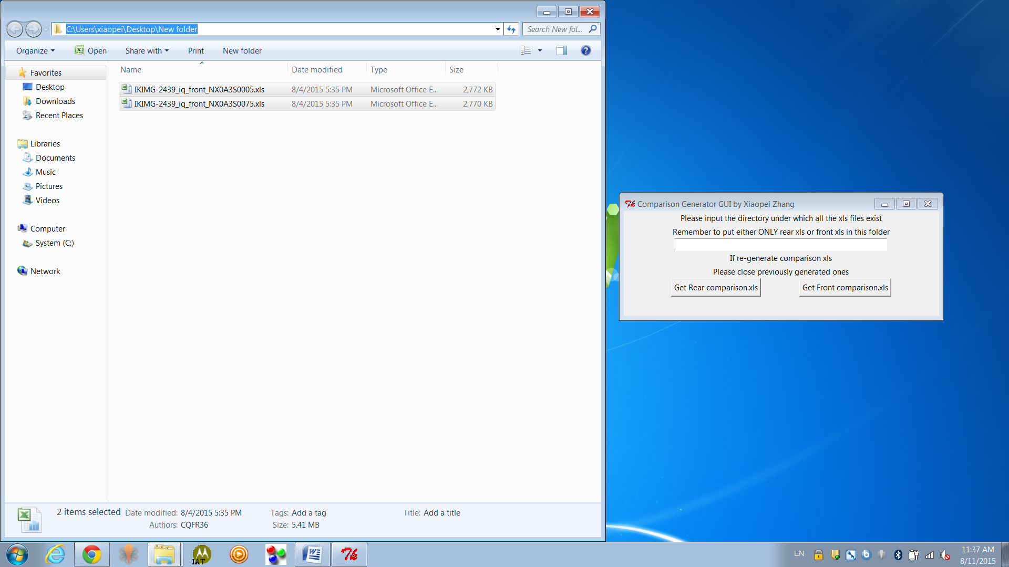
- If you want rear comparison, click Get Rear comparison.xls; If you want front comparison, click Get Front comparison.xls
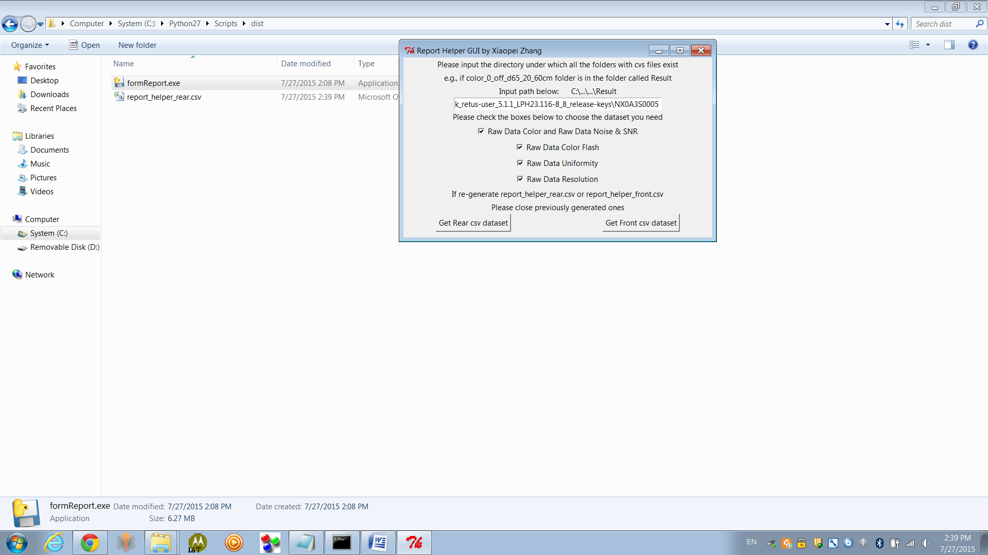
- Check whether the xls files exist. It should be under the same folder where this tool exists
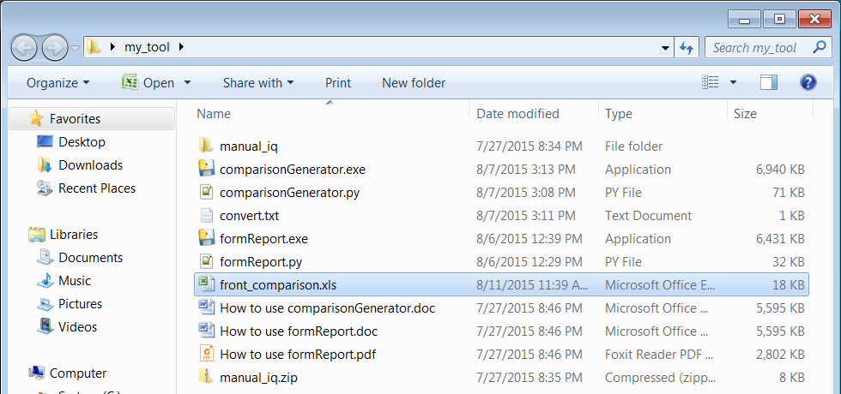
- Open xls files, and it is done. Modify it if you like. Above Measured Values are xls file names
